Expert process diagram of biomarkers which influence their suspicion that a critically ill patient has developed a secondary neurological injury. Namely Delirium, Seizures, or Structural injury.

Clinicians were given a list of 54 variables (nodes).
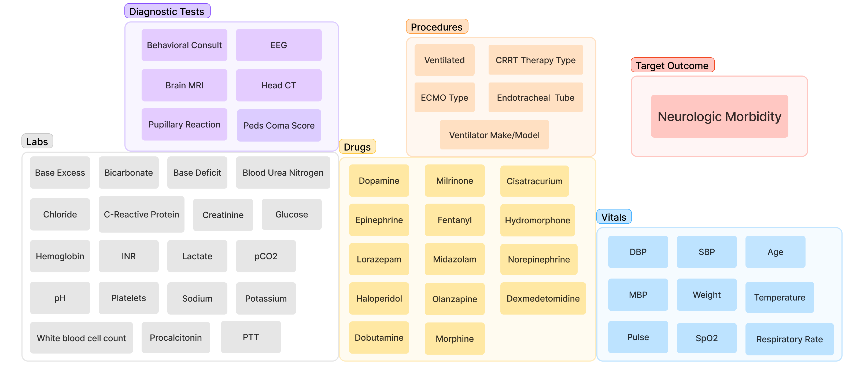
There nodes could b e connected to each other through a combination of 1,431 edges. To help us limit the search space, clinician chose the edges they found to be most salient for them.

After the first iteration, we obtained the following DAG:
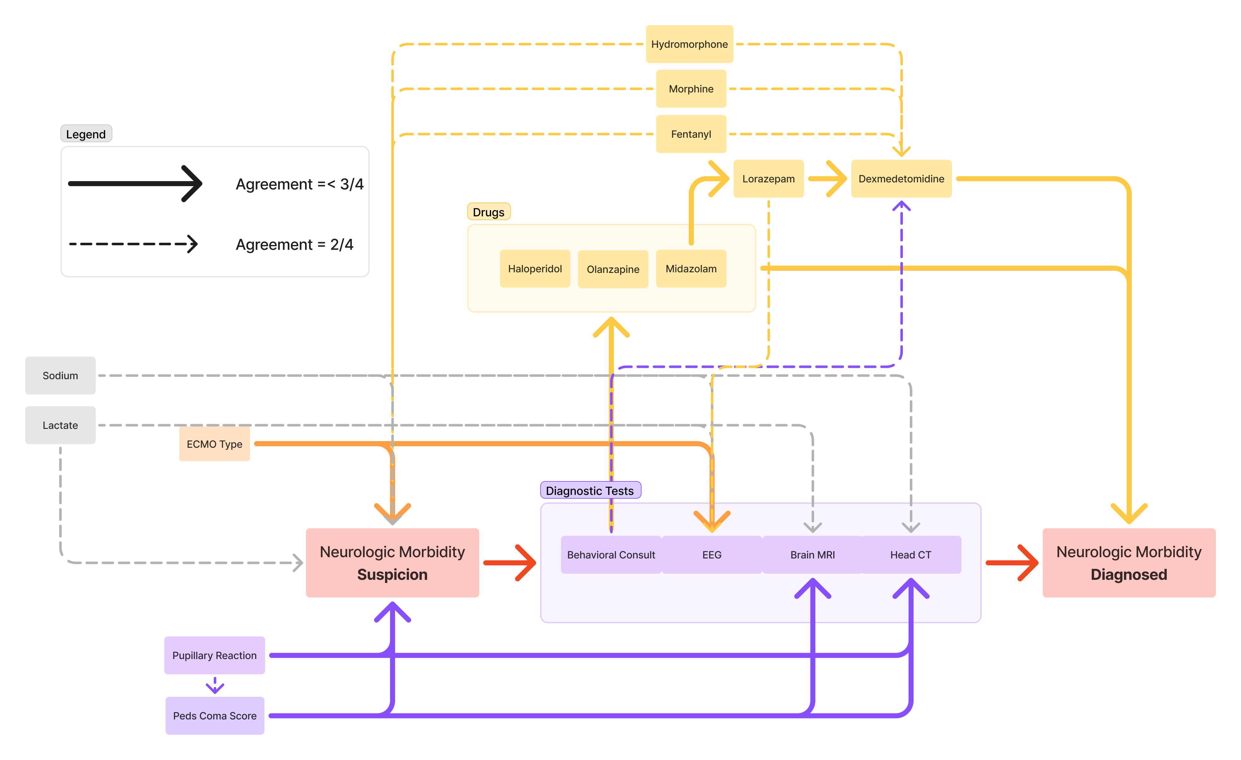
Fleiss’ Kappa for this iteration was 0.195 which reflect poor alignment across clinicians/raters. To improve inter-rater reliability, we had a session where clinicians were able to discuss their choices for the first iteration with each other. Then, we performed a second iteration.

Below is the DAG we obtain after the second iteration:
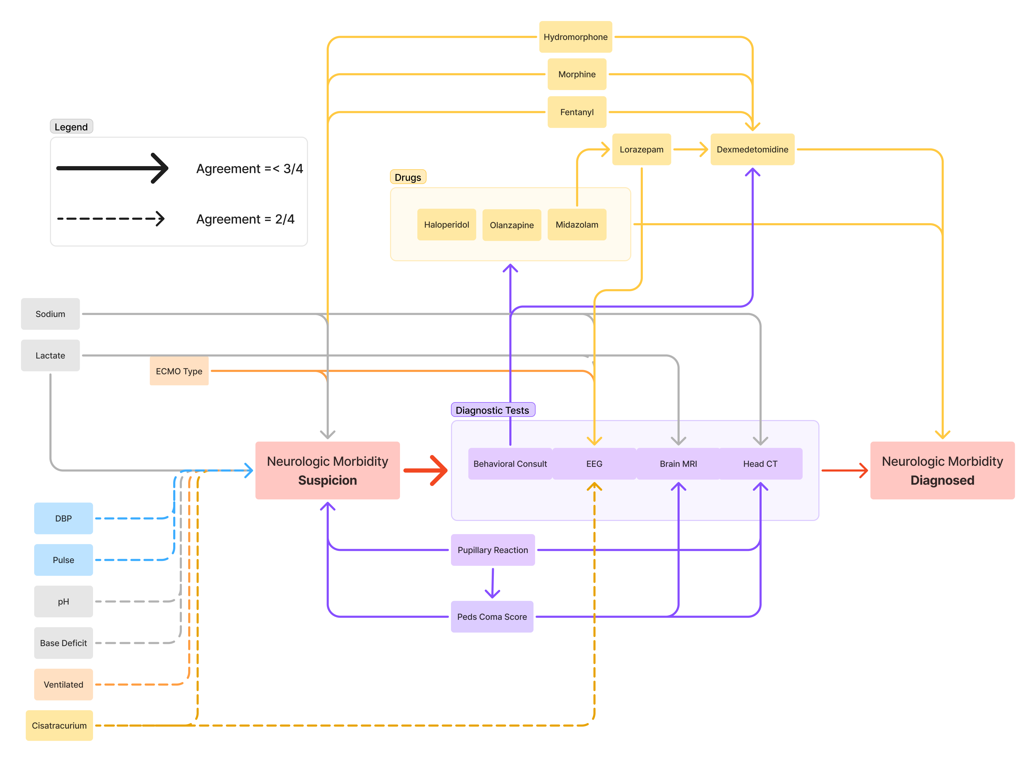
Fleiss’ kappa for the second iteration is 0.62, this is a 0.425 increase and indicates a good level of reliability across raters. If we remove Rater #4, who has the least agreement, Fleiss’ kappa increases to 0.66.

